IPDTBLBA
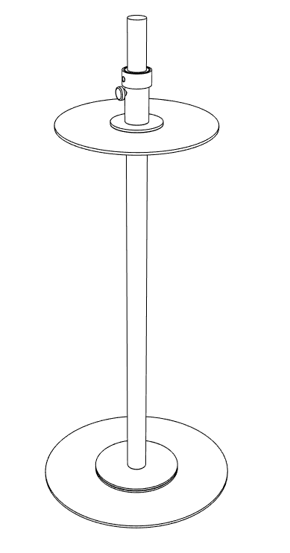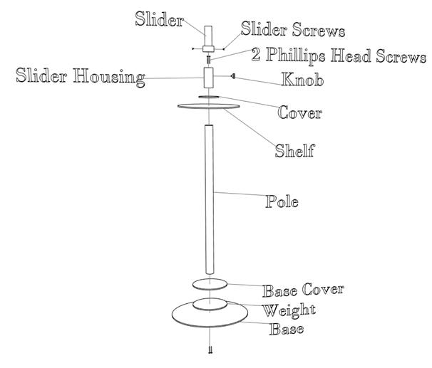
Completed Stand Exploded Diagram

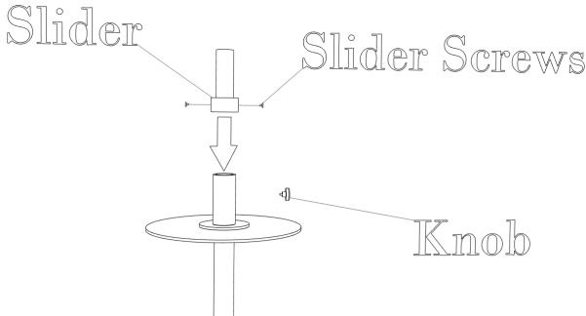
- Use two Philips head screws to assemble slider housing over the cover on the shelf to the pole.
- Insert the slider into the slider housing
- Tighten the slider screws. Then install knob.

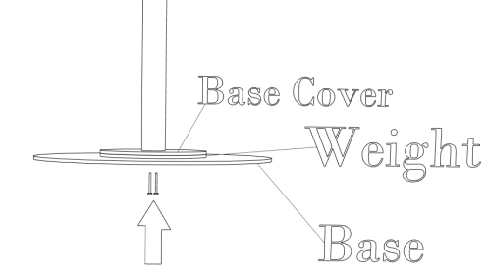
- For the base assembly place the base cover on the pole then weighted base portion then the base use the two screws to attach the base.

