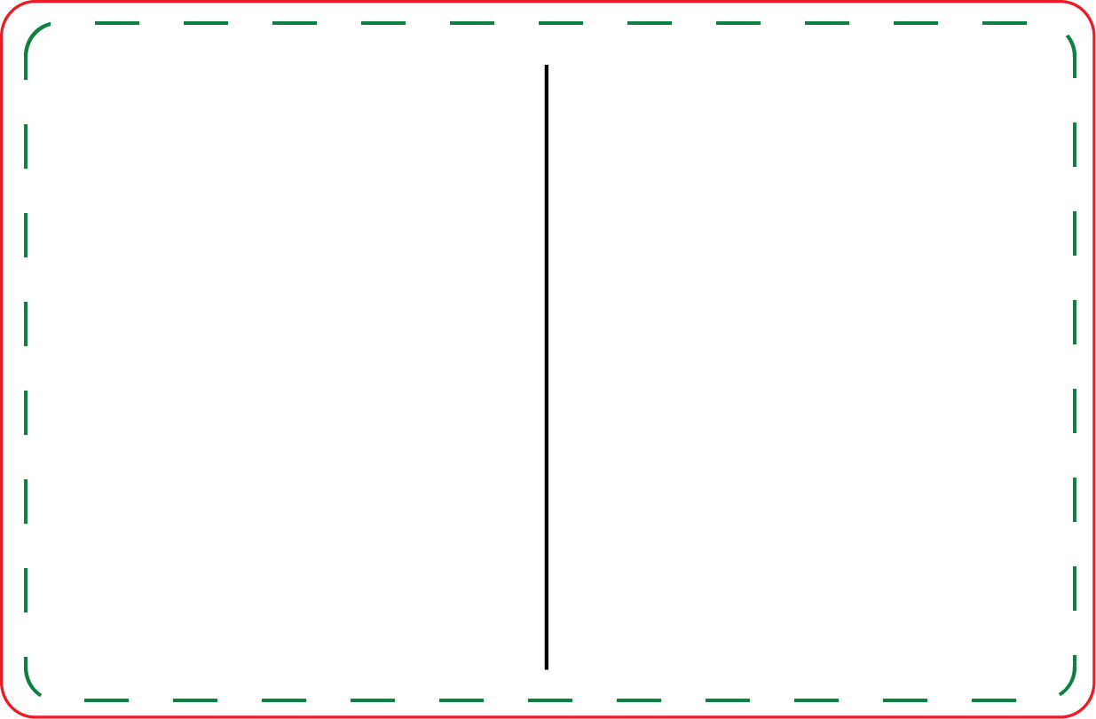

- Customize Prize inserts
- Print on 8.5 x 11 paper
- Cut on dotted line
- Have FUN!!!
Mini Prize Drop - Prizes

