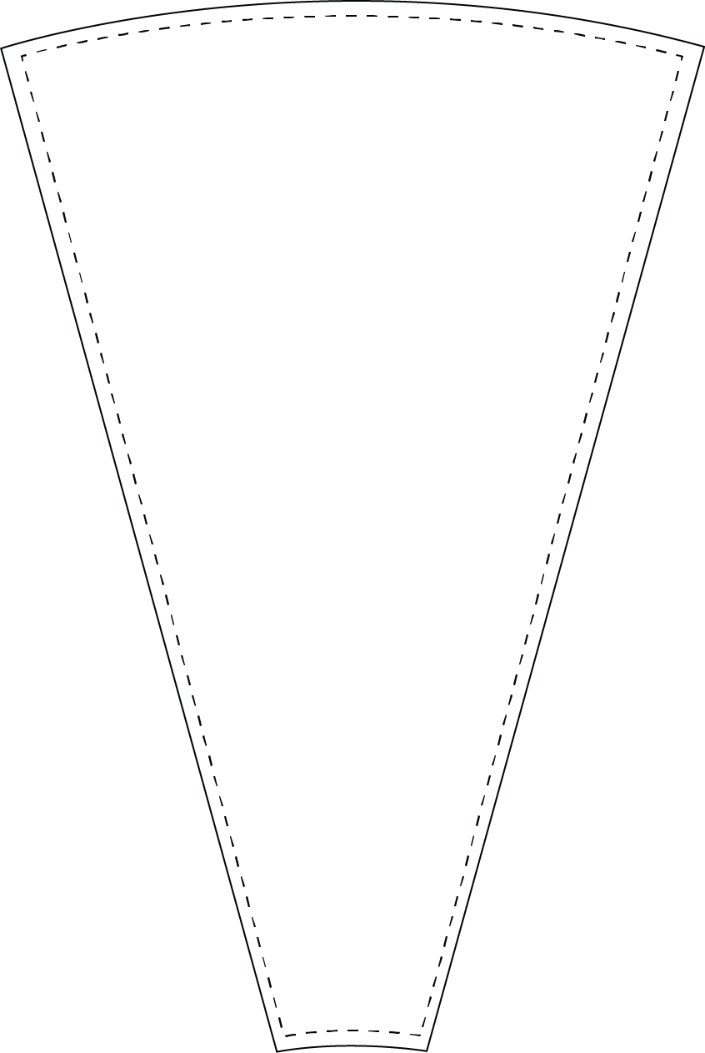

Updated: 082814-lp

1. Customize insert.
2. Print on 8.5 x 11 paper.
3. Cut on dotted line.
4. Have FUN!!!



**26 inch - 12 Slot Wheel**